CL3001
Computer Networks - Lab
Lab 13 & Week-13
Objectives:
- To simulate dynamic routing protocols such as RIP, EIGRP, and OSPF.
Task 1:
Implement RIP protocol for network topology given below. Use IP addressing scheme as mentioned in the picture.
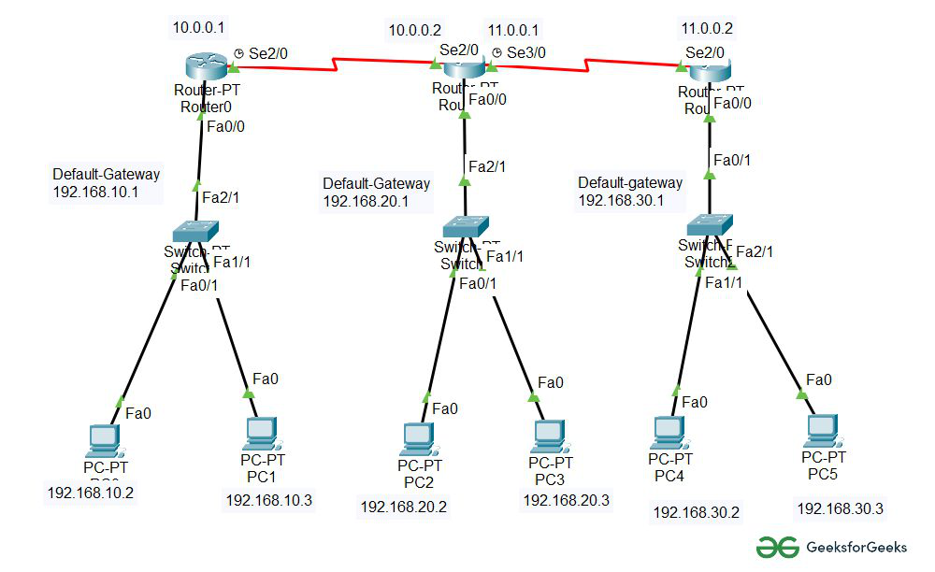

Task 2:
Implement EIGRP protocol for network topology given below. Use IP addressing scheme as mentioned in the picture.
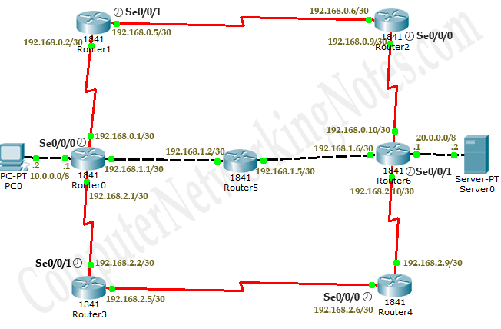

Task 3:
You have learned IP Addressing classes, CIDR and their fix length subnet mask (FLSM) and variable length subnet mask VLSM. Also, you have practice of static routing between networks in previous labs. Now you are required to configure the given topology using the above-mentioned concepts except routing. For this, topology is given with IP: 100.0.0.0 & subnet mask: 255.0.0.0. You are required to create subnetworks but with required Host IDs using VLSM technique for the sub-netting of the given IP address. Also configure Dynamic Routing using OSPF Algorithm between the networks. You are supposed to perform overall configuration using CLI mode on routers.
Note: Clearly perform each step from scratch to generate the required subnets and their IP address, now configure topology using these IPs and subnets and perform topology Dynamic routing testing. Each step has marks, so be careful.
